**Guidelines:**

* In one page, a maximum of 5 MCQs and a minimum of 2 MCQs can be included.
* Questions Numbered 1 to 35
* The font name is Calibri (Body), and the size is 12.
* The primary part of the code must be in bold.
* The four choices should be labeled in uppercase, from A to D, followed by**).**
* All choices must begin with a tab space.
* Write each option on a new line.
* Write the correct answer as shown above, without a tab space after all the options.
* Leave a one-line gap between each question.
* True/False type questions can also be written.

**Note:** Without practice, don't simply copy and paste from other websites. If you feel it's worthwhile, change the values and process, then put it into the document.

1. Select the correct result of the following expression **7**2*2**2**2**

A) 0

B) 562

C) 784

D) 783

**Answer: C**

2. Select the correct result of the following expression **2**2**3**

A) 256

B) 246

C) 64

D) 78

**Answer: A**

3. What is the result of following code:

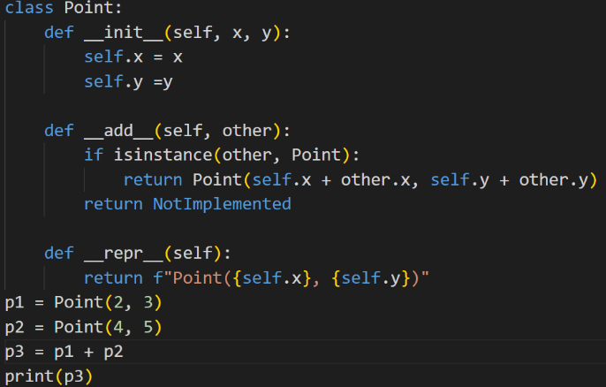

1. Point(6,8)
2. Point(4,5)
3. Point(2,3)
4. Point(7,9)

**Answer**: **A**

4. What is the result of the following bitwise operation: **12 & 5**?

A) 2

B) 4

C) 6

D) 8

**Answer: B**

5. Which bitwise operation is used to toggle (flip) all bits of an integer?

A) AND (&)

B) OR (|)

C) XOR (^)

D) NOT (~)

**Answer: D**

6) Which of the following is true about the bitwise AND operation?

A) It sets each bit to 1 if both corresponding bits are 1

B) It sets each bit to 0 if both corresponding bits are 0

C) It sets each bit to 1 if at least one of the corresponding bits is 1

D) It inverts each bit of the integer

**Answer: A**

7) How can you determine if a number is odd using bitwise operations?

A) Check if the number AND 1 is 1

B) Check if the number OR 1 is 0

C) Check if the number XOR 1 is 1

D) Check if the number AND 2 is 0

**Answer: A**

8) what is the output of the bitwise operation**: 0&7?**

A) 0

B)7

C)5

D)9

**Answer: A**

9)What is the value of result?

**number = 57 # binary: 00111001**

**mask = 0x0F # binary: 00001111**

**result = number & mask**

A)0

B)57

C)9

D)None

**Answer: C**

10) What does the expression **not(10 == 9**) evaluate to?

A) True  
B) False  
C) Error  
D) None of the above

**Answer: A**

11)  What does the expression **3 != 3 or 5 > 4** evaluate to?

A) True  
B) False  
C) Error  
D) None of the above

**Answer:**A

12) What is the output of python command, **print(24.0/4**)?

A)6.0

B)6

C)error

D)None

**Answer: A**

13)  What does the expression **3 != 3 or 5 > 4** evaluate to?

A) True  
B) False  
C) Error  
D) None of the above

**Answer: A**

14) what value does result print?

**x = 240**

**result = (x >> 3) & 0xFF**

A) 30

B) 40

C) 50

D) 20

**Answer: A**

15) What is the output of the following code?

**x = [1, 2, [3, 4]]**

**print(3 in x)**

A) True

B) False

C)Error

D)None

**Answer: B**

16) Output of the following code?

**x = {1: "a", 2: "b", 3: "c"}**

**print (1 in x and "a" in x)**

A) True

B) False

C)Error

D)None

**Answer: B**

17) What is the output of the following Python code?

**x = True**

**y = False**

**z = True**

**result = x or (y and z) and not x**

**print(result)**

A) True

B) False

C) Error

D) None

**Answer: A**

18) What is the output of the following Python code?

**a = [1, 2, 3, 4, 5]**

**b = a**

**c = [1, 2, 3, 4, 5]**

**result = (4 in a) and (a is b) and (c is not a) and (3 in c) and (b != c)**

**print(result)**

A) True

B) False

C) Error

D) None

**Answer: A**

19) What is the output of the following code?

**x = 5**

**result = x << 3**

**print(result)**

1. 40
2. 50
3. 60
4. None

**Answer: A**

20) What is the output of the following code?

**print(3^3^5^5^7^7^7)**

1. 7
2. 5
3. 3
4. None

**Answer: A**

21) What is the output of the following code?

**A = True (Alice is guilty)**

**B = False (Bob is innocent)**

**C = True (Charlie is guilty)**

**condition_1 = (A and not B) or (not A and B)**

**condition_2 = (B and not C) or (not B and C)**

A) Alice is guilty, Bob is innocent, Charlie is guilty  
B) Alice is innocent, Bob is guilty, Charlie is innocent  
C) Alice is guilty, Bob is guilty, Charlie is innocent  
D) Alice is innocent, Bob is innocent, Charlie is guilty

**Answer: A**

22) What is the output of the following code:

**x = 5**

**y = 10**

**x = x ^ y**

**y = x ^ y**

**x = x ^ y**

**print(f"x = {x}, y = {y}")**

1. x=10, y=5
2. x=15, y=10
3. Error
4. None

**Answer: A**

23) what is the output of the following code:

**def check_power_of_2(n):**

**return n > 0 and (n & (n - 1)) == 0**

**n = 16**

**print(check_power_of_2(n))**

A) True

B) False

C) Error

D) None

**Answer: A**

24) You are given the string **s = "Python programming is fun"** and the list **substrings = ["Python",** **"gram", "Java", "fun", "prog"]**.

Which of the following is the correct list of boolean values indicating the presence of each substring in s?

A) [True, False, True, False, True]  
B) [True, True, False, True, False]  
C) [True, True, False, True, True]  
D) [False, True, False, True, True]

**Answer: C**

25) Given the string **s = "Hello, World!",** which of the following expressions correctly checks if the character 'e' is present in the string s?

A) 'e' in s  
B) 'e' not in s  
C) s.contains('e')  
D) s.indexOf('e') != -1

**Answer: A**

26) What is the output of the following code?

**nums = [1, 3, 5, 7, 9]**

**n = 7**

**result = (n % 2 != 0 and n in nums) * 2 or n / 2**

**print(result)**

1. 2
2. 4
3. 3
4. 7

**Answer: A**

27) What is the output of the following code?

**data = [5, 7, 5, 3, 7, 9, 9]**

**sum = 0**

**for num in data:**

**sum ^= num**

**print(sum)**

1. 34
2. 55
3. 3
4. 7

**Answer: C**

28) What is the output of the following code?

**list1 = [1, 2, 3, 4]**

**list2 = [1, 2, 3, 4]**

**result = (list1 == list2) and (list1 is list2)**

**print(result)**

A) True

B) False

C) Error

D) None

**Answer: B**

29) What is the output of the following code?

**s = "hello world"**

**char_list = ['h', 'e', 'l', 'o', 'w', 'r', 'd']**

**result = any(char in s for char in char_list) and sum(s.count(char) % 2 == 0 for char in char_list)**

**print(result)**

A) True

B) False

C) Error

D) None

**Answer: A**

30) what is the output of the following code:

**list1 = [10, 20, [30, 40], 50]**

**list2 = [10, 20, [30, 40], 50]**

**result = (list1 == list2) or (list1[2] is list2[2])**

**print(result)**

A) True

B) False

C) Error

D) None

**Answer: A**

31) What is the output of the following code:

**x = 12**

**nums = [3, 6, 9, 12, 15]**

**result = ((x % 3 == 0) and (x % 5 != 0) and (x % 2 == 0) and (x in nums)) * 2 or (x / 2)**

**print(result)**

1. 12
2. 2
3. 7
4. 24

**Answer: A**

32) Given the integer **x = 15**, and the operation **x = x >> 1**, which of the following is the correct result?

A) The number becomes even  
B) The number becomes odd  
C) The result is 7  
D) The result is 8

**Answer:** **C**

33) What will be the result of the **operation x = -16 >> 2 for a signed integer and an unsigned integer**?

A) Same for both signed and unsigned  
B) Signed integer gives -4, unsigned gives 4  
C) Signed integer gives 4, unsigned gives -4  
D) Same result, but different sign representations

**Answer:** **B**

34) What happens when you shift a **32-bit signed integer** with the maximum value (x = 2147483647) to the left by 1 position?

A) No overflow  
B) Overflow, value becomes negative  
C) Overflow, value becomes zero  
D) No effect on the value

**Answer:** **B**

35) Which of the following expressions is equivalent to **multiplying x = 7 by 8** using a left shift operator?

A) x = x << 1  
B) x = x << 2  
C) x = x << 3  
D) x = x << 4

**Answer:** **C**